*LAB # 05*

cpu scheduling algorithms-1

# *OBJECTIVE:*

*To simulate CPU Scheduling Algorithms. (First Come First Serve, Shortest Job First).*

*LAB task*

1. *Write a program which takes as an argument at least 10 CPU Brust time. Calculate CPU utilization, average waiting time, turnaround time and response time using SJF(Non-Preemptive) and SJF(Preemptive). Display a text-based Gantt chat on the screen.*

***CODE:***

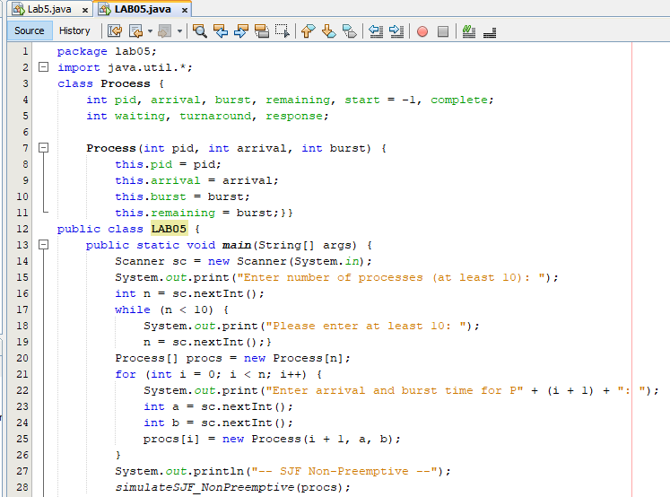

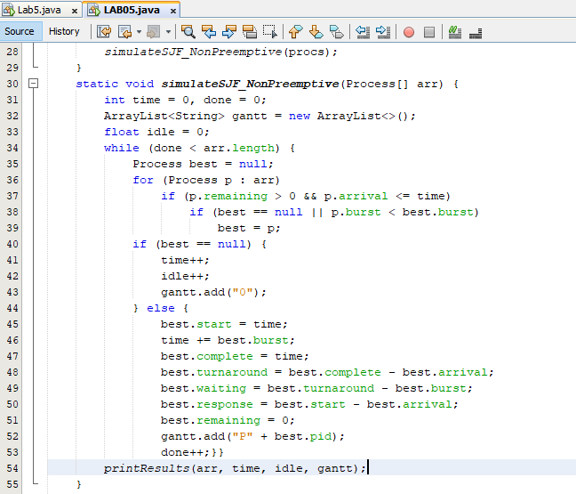

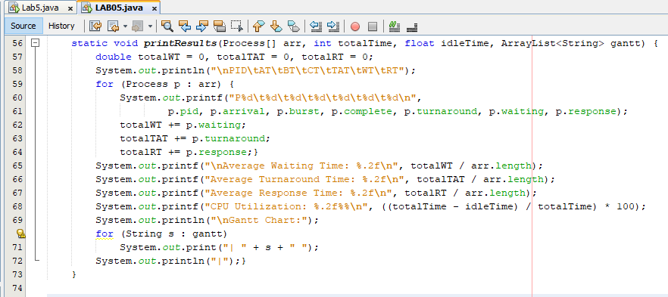

***OUTPUT:***

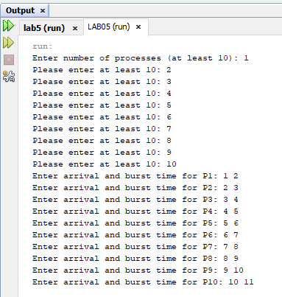

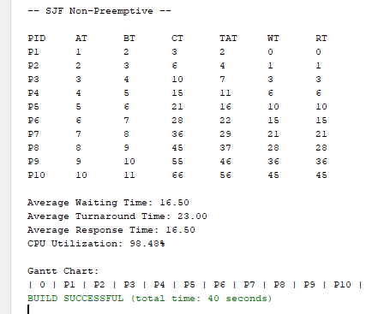

1. *Write a program which takes as an argument at least 15 CPU Brust time. Calculate CPU utilization, average waiting time, turnaround time and response time using FCFS. Display a text-based Gantt chat on the screen*

***CODE:***

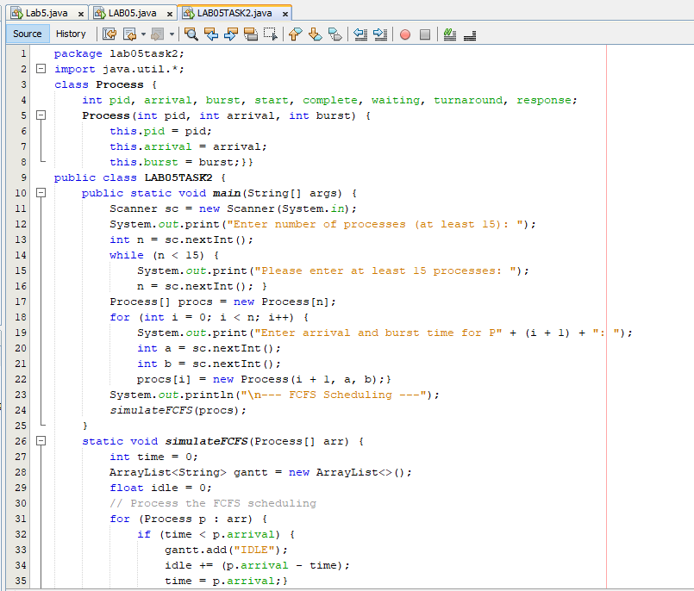

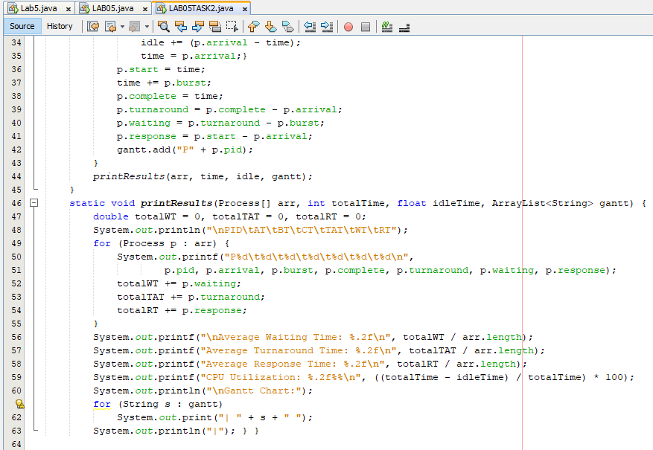

***OUTPUT:***

